Republic of the Philippines



Department of Education

National Capital Region

**Batasan Hills National High School**

IBP Road Batasan Hills, Quezon City

Feasibility of Coconut Pulp (*Cocos nucifera L.*) with Malunggay Pellets (*Moringa oleifera*) as an Alternative Poultry feed

Denise Joyle  J. Cabu-ay

VII STE – Cassiopeia

**Researcher**

**ABSTRACT**

The rising costs of commercial poultry feed and the need for sustainable agricultural practices have driven research into alternative feed sources. This study evaluates the feasibility of Moricoco Pellets, a blend of coconut pulp (*Cocos nucifera*) and malunggay (*Moringa oleifera*), as a cost-effective and nutritious poultry feed alternative. Coconut pulp, often discarded as waste, provides an energy-rich base, while malunggay enhances the nutritional profile with essential vitamins and minerals. The study analyzes the nutritional content and cost-effectiveness of Moricoco pellets compared to commercial feeds through laboratory testing and price analysis. This study highlights that Moricoco pellets are easy to produce with readily available materials. Due to time constraints, laboratory results for their nutritional content were not obtained, preventing a full analysis. However, cost analysis shows that Moricoco pellets are 78% cheaper than commercial poultry feed, making them a highly cost-effective alternative. By repurposing local and often discarded materials, the formulation supports both economic savings and sustainability in poultry farming. While the financial benefits are clear, further research is needed to evaluate their nutritional value and impact on poultry growth. Future studies should include controlled feeding trials and detailed nutritional assessments to confirm their long-term feasibility.

**I. INTRODUCTION**

The growing global demand for sustainable and cost-effective poultry feed has prompted researchers and experts in the agricultural and animal nutrition fields to investigate new and innovative sources of nutrition (Bahadur et al, 2024). These alternative sources aim to optimize feed formulations while addressing pressing environmental concerns linked to agricultural waste.

*Cocos nucifera*, commonly known as the coconut tree, is a remarkable member of the Arcaceae family, celebrated for its diverse applications and contributions to both the economy and local cultures. Coconut pulp, often seen as a byproduct in the processing of coconuts, is frequently discarded, contributing to environmental waste. With the rising demand for affordable poultry feed, this underutilized resource presents a promising opportunity for sustainable agricultural practices. By repurposing coconut pulp, we can not only minimize environmental waste but also address the economic challenges faced by poultry farmers seeking cost-effective feed alternatives. This study aims to explore the potential of coconut pulp as a viable ingredient in poultry rations, particularly when combined with nutritious additions such as malunggay. Known for its rich nutritional profile, malunggay provides essential vitamins and minerals, complementing the energy-rich benefits of coconut pulp (Islam et al, 2021). Malunggay (*Moringa oleifera*) is recognized as a "superfood" due to its high protein, vitamin, and mineral content. Malunggay leaves are readily available in many regions and can be processed into pellets for easy incorporation into animal feeds (Srinsava & Pandey, 2023)

Recent research has revealed that incorporating coconut products into poultry diets can significantly enhance various health aspects of the birds. Studies indicate that these products, particularly coconut oil and coconut pulp, can improve digestion (Rusdiansyah et al, 2022), leading to better nutrient absorption and utilization. As a result, poultry fed with coconut-based diets often show increased growth rates and improved overall health, which are vital factors for farmers aiming to optimize production efficiency and maintain the well-being of their flocks (Obianwuna et al, 2023).

In addition to the health benefits for chickens, using coconut products and malunggay has substantial economic implications for farmers. By integrating coconut pulp into their feeding strategies, poultry producers can effectively reduce feed costs while simultaneously minimizing waste. Malunggay is easily grown and can be harvested fast. This approach not only supports sustainability practices by diverting coconut waste from landfills but also addresses economic challenges faced by farmers in the competitive poultry industry. It serves as a promising avenue for cost reduction, making poultry farming more viable and profitable.

Moricoco Pellet is the name of the product which consists of Coconut pulp and malunggay pellets as an alternative poultry feed significantly improve the growth performance, health, and cost-efficiency of poultry compared to commercial poultry feed. These hypotheses align with your research objective to test the feasibility and effectiveness of the alternative feed

The study is significant because it addresses some of the biggest challenges faced by poultry farmers today. With the rising costs of the commercial poultry feed, many small-scale farmers struggle to sustain their operations. By exploring coconut pulp and malunggay pellets as alternative feed ingredients, this research offers a practical solution that could make poultry farming more affordable and accessible. Coconut pulp, which is often treated as waste, can be repurposed into a valuable feed ingredient. At the same time, malunggay, known for its high nutritional value, could improve poultry health and productivity. Together, these natural resources could help farmers save money while maintaining the quality of their poultry products. This study also promotes sustainability by making use of agricultural byproducts and locally available materials. This could reduce waste and encourage farmers to adopt more environmentally friendly practices. Additionally, if the alternative feed proves effective, it could improve food security by making poultry farming more profitable and efficient, which benefits both farmers and consumers. Ultimately, this research is about helping farmers, protecting the environment, and contributing to a sustainable food system. The findings could pave the way for new, innovative feeding strategies in the poultry industry, benefiting communities and the agricultural sector.

The main goal of the study is to find out if coconut pulp and malunggay pellets can work as an alternative to commercial poultry feed. With the rising costs of feed, the researcher desires to explore if using these natural and locally available materials can help farmers save money while keeping their poultry healthy and productive. It’s important to ensure that their health isn’t compromised and that the feed supports good weight gain and overall development. Beyond economic benefits, this study also promotes sustainable agricultural practices by utilizing coconut pulp, a byproduct that is often discarded, and malunggay, a nutrient-dense and easily cultivated plant. By repurposing agricultural waste and locally available resources, the research supports a circular economy and encourages more eco-friendly, low-waste farming methods.This approach can help reduce dependence on imported feeds**,** lower farming costs, and contribute to environmental conservation by minimizing waste. The researcher hopes that this study can provide useful data for other researchers and farmers who are looking for affordable and sustainable ways to improve poultry farming. If successful, this could be a big help to small-scale farmers and the agricultural community as an economic means to feed their livestock.

The research questions of the study are the following:

**General Questions**

In general, the researcher aims to answer the question:

Is the use coconut pulp and malunggay pellets more effective for farmers instead of using traditional poultry feed?

**Specific Questions**

1. What are the specific nutritional content of Moricoco pellets.

2. What are the difference of costs between Moricoco pellets and standard chicken feed?

3. Is there a significant difference on the nutritional content of Moricoco pellets compared to commercial poultry feed?

**Hypothesis**

The hypotheses for the study are:

$N_{0}$: There is no significant difference between Moricoco pellets and commercial poultry feed.

$N_{A}$: There is a significant difference between Moricoco pellets and commercial poultry feed.

The scope of the study is focused on evaluating coconut pulp and malunggay pellets as alternative feed for broiler chickens. The study will assess the difference between price and nutrition content of commercial poultry feed in comparison to the Moricoco pellets. The main aim of the study is to determine whether these alternative feed ingredients are cost-effective and sustainable for poultry farming, particularly for small-scale farmers. Laboratory tests will be conducted to analyze the nutritional composition of coconut pulp and malunggay pellets to ensure they meet the necessary dietary needs of poultry, as well as price analysis for locally available poultry feed. This research will provide valuable insights into whether these locally sourced ingredients can be used effectively as alternatives to commercial poultry feed.

The delimitations of this study involve certain factors that limit its scope and generalizability. First, the study will only focus on the price and nutritional content of Moricoco pellets in comparison with commercially available pellets. Another factor is ease of manufacture, specifically whether these pellets are more cost-effective for production by local farmers. For the meantime, the study will not focus on how Moricoco affects broiler chicken growth, but this can be done in future studies, Additionally, the study will not account for variations in pellet formulation beyond the tested composition, nor will it assess the long-term effects of Moricoco pellet consumption on animal health and productivity. The research will also be geographically limited to a specific region, and as such, external factors such as climate, soil conditions, and feed availability in other areas will not be considered. Furthermore, the study will not examine the broader economic impact of adopting Moricoco pellets on the livestock industry or supply chain logistics. These delimitations help clarify the specific focus of the study while acknowledging the factors that may influence its scope and applicability.

**II. METHODOLOGY**

**Research Design:**

This study will utilize an experimental research design to determine the feasibility of coconut pulp (*C. nucifera L.*) and malunggay pellets (*M. oleifera*) as alternative poultry feed.

The study will follow a systematic approach to procure materials, create Moricoco pellets, analyze their nutritional content and price range, and compare them with standard poultry feed using statistical methods.

1. **Material Collection and Preparation**

First, the necessary materials will be gathered, including malunggay leaves which are readily available, coconut pulp which is relatively cheap to procure, cornstarch as an aggregate, two 500g commercially available poultry feeds for comparison, a manual pellet machine, and appropriate storage containers, and a small weighing scale for measuring the weight of the produced pellets in grams. The malunggay leaves and coconut pulp will serve as the primary ingredients for Moricoco pellets, while cornstarch will act as a binding agent to ensure proper pellet formation.

The price of the commercially available pellets will be recorded, while the production cost of the Moricoco pellets—including raw material costs, labor, and equipment usage—will also be determined. This cost analysis will allow for a direct comparison of the economic viability of Moricoco pellets versus traditional poultry feeds.

1. **Moricoco Pellet Manufacture**

Once the materials are acquired, the process of creating the Moricoco pellets will begin. The malunggay and coconut pulp will be mixed in varying weight ratios of **20:80, 40:60, 50:50, 60:40, and 80:20** (referred to as 80M20C by percentage of malunggay and coconut) to determine the optimal formulation for poultry nutrition. These ratios will be tested to assess the best balance between nutrient content, palatability, and pellet stability. In each mixture, **40 grams of cornstarch** will be added as a pellet aggregate to enhance the structural integrity of the pellets, ensuring they remain compact and do not easily disintegrate during handling and storage.

After thoroughly mixing the ingredients, the resulting mixture will be processed through a **manual pellet machine** to create an initial mulch. Afterwards, cornstarch will be added to the mulch that then uniform feed pellets. This machine compacts the mixture into cylindrical shapes that facilitate easier feeding and digestion for poultry. Since the freshly formed pellets retain a significant amount of moisture, an initial **microwave drying process** will be conducted for approximately **one minute** to reduce excess moisture and prevent spoilage. The microwaving step also helps to partially gelatinize the starch, improving pellet cohesion and durability.

Following the microwave drying process, the pellet batches will be **spread out in an open-air environment** and left overnight for further drying. This air-drying step ensures that any remaining moisture evaporates gradually, preventing mold growth and spoilage during storage. Once completely dried, the final **Moricoco pellets will be weighed, inspected, and stored in airtight containers** to maintain freshness and extend shelf life. The resulting pellets are then dry and ready for long term storage.

1. **Nutrition Content Testing**

After pellet production, both the Moricoco pellets and the selected commercial poultry feeds will undergo nutritional analysis. The samples will be tested at Philippine Institute of Pure & Applied Chemistry (PIPAC) to assess their nutritional composition, including protein, fiber, fat, vitamins, and minerals. This analysis will provide quantitative data on the nutrient content of Moricoco pellets compared to standard poultry feed.

**D. Price Analysis and Comparison**

The recorded price from commercially available feed and will be compared to the cost of procurement and creation of the Moricoco pellets. Due to the relatively small sample size for price comparison, no statistical testing can be done, and instead the mean of the commercial values will be directly compared to the cost of production of Moricoco pellets as a preliminary analysis.

**E. Data Analysis and Comparison**

The data analysis will be conducted based on the nutritional composition obtained from laboratory testing of Moricoco pellets and commercial poultry feed. Multiple samples of Moricoco pellets, formulated with varying malunggay-to-coconut pulp ratios, will undergo quantitative assessment to determine their protein, fiber, fat, vitamin, and mineral content. These results will then be systematically compared to the nutritional profile of commercially available poultry feed to evaluate relative differences in composition.

To determine statistical significance, the study will employ a two-sample t-test to compare the means of the nutritional values between Moricoco pellets and standard poultry feed. The test will be conducted at a significance level of $α = 0.05$ ( $p ≤ 0.05)$ to assess whether the observed differences are statistically significant. If the $p$-value obtained is less than or equal to 0.05, the null hypothesis (which states that there is no significant difference between Moricoco pellets and commercial feed) will be rejected in favor of the alternative hypothesis, indicating a significant difference in nutritional content. Additionally, ANOVA may be utilized to analyze the variation in nutritional content across different Moricoco formulations to identify the most nutritionally optimal ratio.

**Ethical considerations:**

Ethical considerations are important in this study on using coconut pulp (*Cocos nucifera L.*) and malunggay pellets (*Moringa oleifera*) as alternative poultry feed. The researcher will ensure transparency, accuracy, and responsible research practices. Data on the nutritional composition of the pellets will be collected and analyzed without bias. The study promotes sustainability by utilizing agricultural byproducts like coconut pulp. Proper documentation and adherence to ethical guidelines for food and agricultural research will be maintained throughout.

**Risk and Safety**

One of the primary risks in this study is contamination and spoilage of raw materials, as improper handling, storage, or processing of malunggay leaves and coconut pulp can lead to microbial growth, spoilage, or mycotoxin formation, which may pose health risks to poultry. To mitigate this, proper drying and storage in airtight, moisture-free containers should be ensured, along with strict hygienic handling procedures. Another concern is the potential for allergic reactions or toxicity in poultry due to excessive consumption of certain compounds in malunggay or coconut pulp, which could lead to digestive issues or other adverse effects. This risk can be minimized through toxicity screening and maintaining ingredient proportions within recommended dietary guidelines. Furthermore, the manual pellet machine used in feed preparation poses a mechanical hazard, with the potential for hand injuries if not operated correctly. To ensure safety, proper training should be provided, protective gloves used when necessary, and machine operation guidelines provided by the manufacturer is strictly followed.

**III. RESULTS AND DISCUSSION**

1. **Nutritional Testing**

Due to the extended processing time at the designated testing center, the nutritional analysis results will not be available within the deadline required for this study (see receipt at Appendices). Consequently, a comprehensive evaluation of the nutritional composition of the Moricoco pellets cannot be conducted within the study’s scope. The absence of these analytical results precludes any quantitative assessment of macronutrient and micronutrient content, thereby limiting the ability to draw meaningful conclusions regarding the nutritional viability of the formulated feed. As such, no meaningful nutritional analysis can be made since the data is still for release

1. **Price Comparison**

The price for both the commercial feed purchased to serve as controls were both Php. 40.00 per Kilogram, thus an average of Php 40 for commercial feeds at least for the feeds available from the region where the feeds are purchased. For the Moricoco pellet materials, the essential ingredients had the following prices: Php. 20 for 1 kilogram of Malunggay, Php. 10 for 4 kilograms of coconut pulp, and Php 15 for 250 grams of cornstarch, which is used as the aggregate. Thus, the average net price for the production of 1 kilogram of Moricoco pellets is: Php 8.57

$$Price per kilo=\frac{\sum{(Material prices)}}{∑(Material weight)}$$

This is calculated by adding the total price of the obtained materials and dividing it by the total weight. However, excluded in this calculation is the cost of the manual pelleting machine, but since we are concerned solely with the pellet production, this is deemed to be acceptable.

***Figure 1.*** Visual representation of the price difference in the purchase of commercial feed pellets compared to the price of Moricoco pellet manufacture

Figure 1 compares the cost of purchasing commercial feed with the production cost of Moricoco pellets using locally available materials. Preliminary analysis shows that Moricoco pellets are significantly cheaper, with a production cost 78% lower than commercial alternatives. This substantial cost difference suggests potential economic benefits for poultry farmers seeking affordable feed options. However, due to the limited sample size, statistical tests such as t-tests cannot be effectively conducted to determine significant differences with high confidence. Despite this limitation, the observed cost reduction highlights the feasibility of Moricoco pellet production as a low-cost alternative to commercial feeds, warranting further investigation into its nutritional efficacy and scalability.

**IV. CONCLUSION**

This study demonstrates that Moricoco pellets, composed of coconut pulp and malunggay, is relatively easy to produce and its materials are very easy to obtain. Due to the time-constraints of the study, the laboratory results for the nutritional content of Moricoco and of commercial feed have not yet been obtained and thus results cannot analysed. However, price analysis of the materials for Moricoco and purchasing commercial pellets present a significantly more cost-effective alternative to commercial poultry feed, with a production cost 78% lower than market options. By utilizing locally available and often discarded materials, the formulation not only reduces feed expenses but also promotes sustainability in poultry farming. While the economic advantage is evident, further research is required to assess the nutritional efficacy of Moricoco pellets and their impact on poultry health and growth. Future studies should incorporate controlled feeding trials and comprehensive nutritional analyses to validate their viability as a long-term alternative in poultry production.

**BIBLIOGRAPHY**

Bist, R. B., Bist, K., Poudel, S., Subedi, D., Yang, X., Paneru, B., Mani, S., Wang, D., & Chai, L. (2024). Sustainable poultry farming practices: A critical review of current strategies and future prospects. *Poultry Science, 103*, Article 104295.<https://doi.org/10.1016/j.psj.2024.104295>

Islam, Z., Islam, S. M. R., Hossen, F., Mahtab-ul-Islam, K., Hasan, M. R., & Karim, R. (2021). *Moringa oleifera* is a prominent source of nutrients with potential health benefits. *International Journal of Food Science, 2021*, Article 6627265.<https://doi.org/10.1155/2021/6627265>

Srivastava, S., & Pandey, V. K. (2023). Dynamic bioactive properties of nutritional superfood *Moringa oleifera*: A comprehensive review. *Journal of Agriculture and Food Research, 14*(11), 100860. https://doi.org/10.1016/j.jafr.2023.100860

Rusdiansyah, R., Hasanuddin, A., & Mulyati, M. (2022). Effect of coconut husk extract on broiler chicken performance, pH and microbial composition of digesta, and small intestine histomorphology. *Journal of the Indonesian Tropical Animal Agriculture, 47*(2), 119-127.<https://doi.org/10.14710/jitaa.47.2.119-127>

Obianwuna, U. E., Chang, X., Oleforuh-Okoleh, V. U., Onu, P. N., Zhang, H., Qiu, K., & Wu, S. (2024). Phytobiotics in poultry: Revolutionizing broiler chicken nutrition with plant-derived gut health enhancers. *Journal of Animal Science and Biotechnology, 15*, Article 169.<https://doi.org/10.1186/s40104-024-00895-6>

**APPENDICES**

**A. Materials**

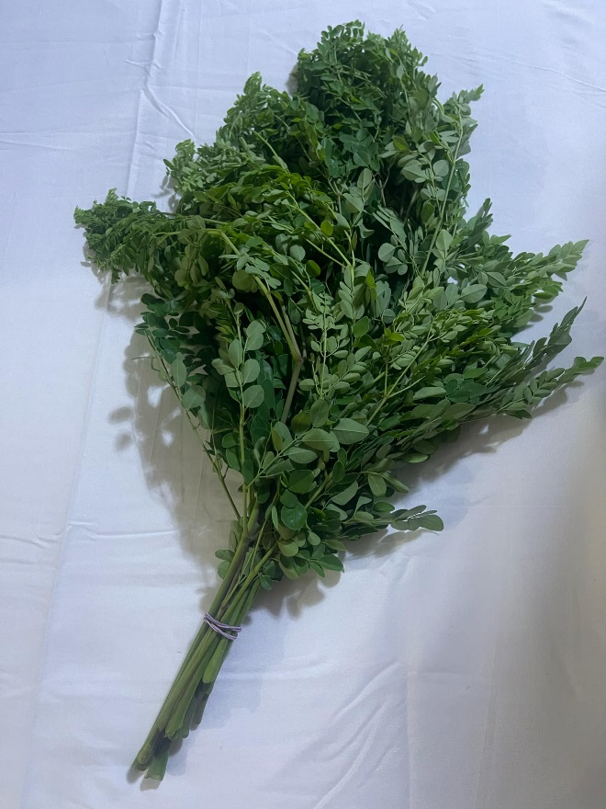 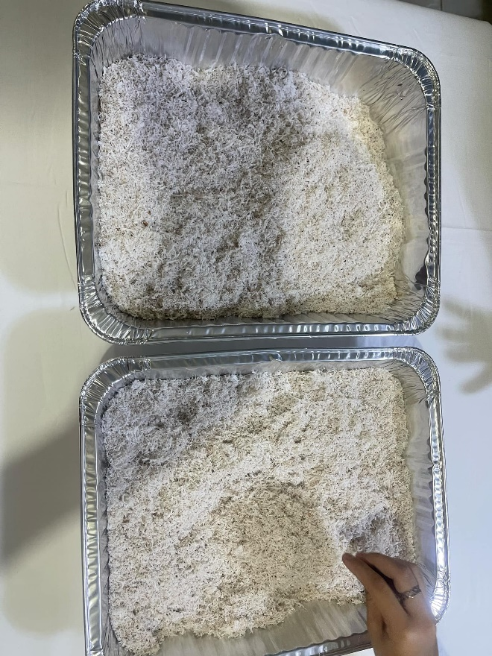

***Figure 2.*** Malunggay Leaves ***Figure 3.*** Coconut pulp

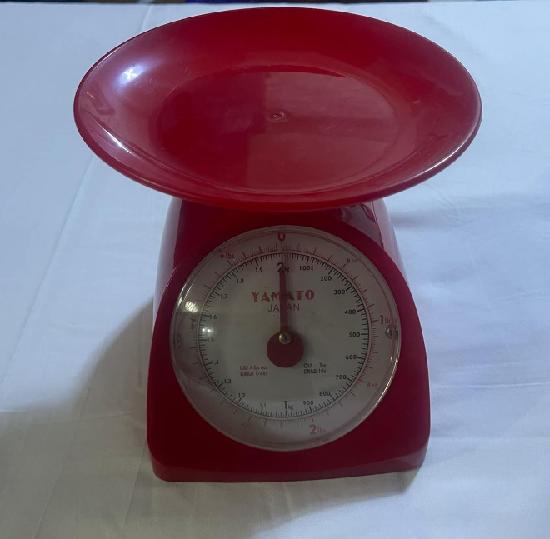 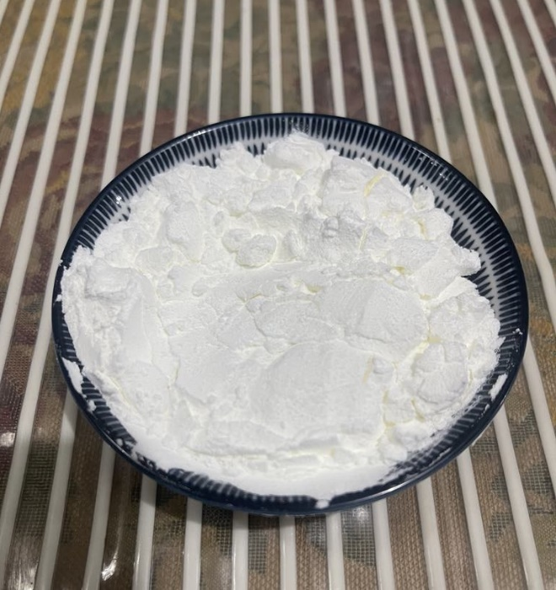

***Figure 4.*** Weighing Scale  ***Figure 5.*** Cornstarch Aggregate

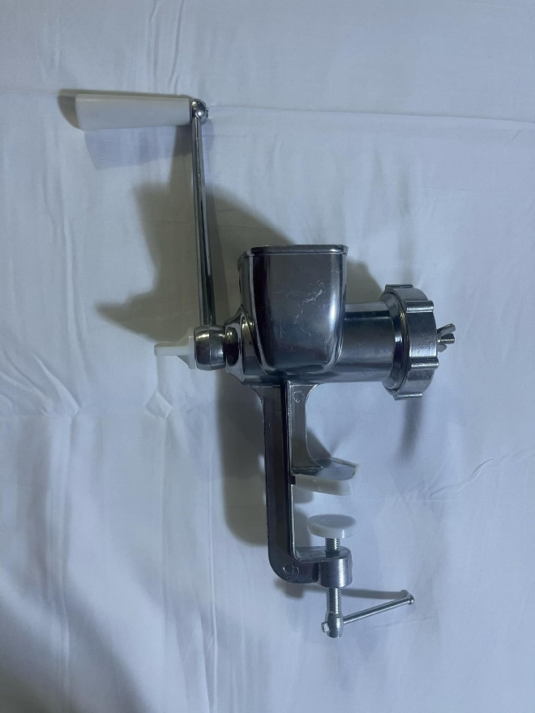 

***Figure 6***. Manual pellet machine ***Figure 7***. Plastic Containers

**B. Pellet Manufacture**

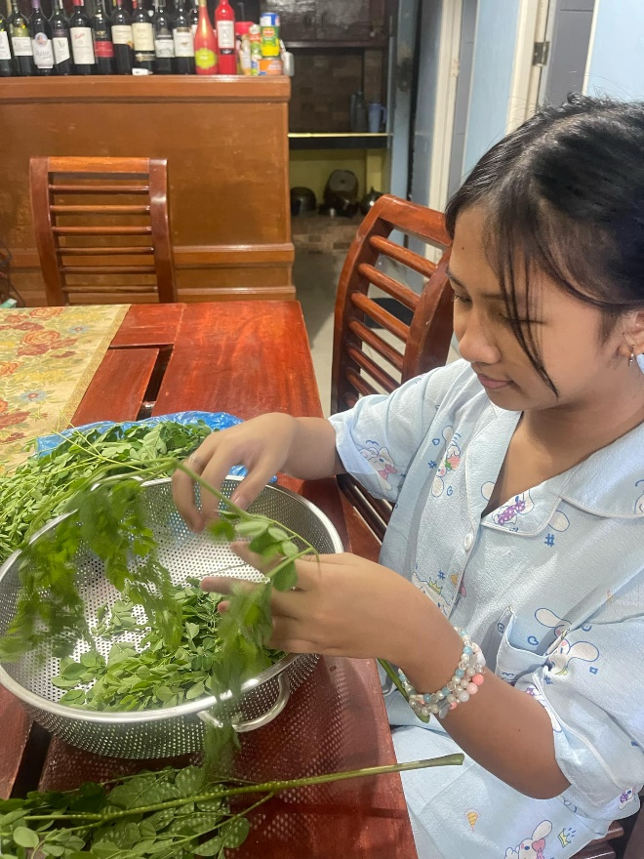 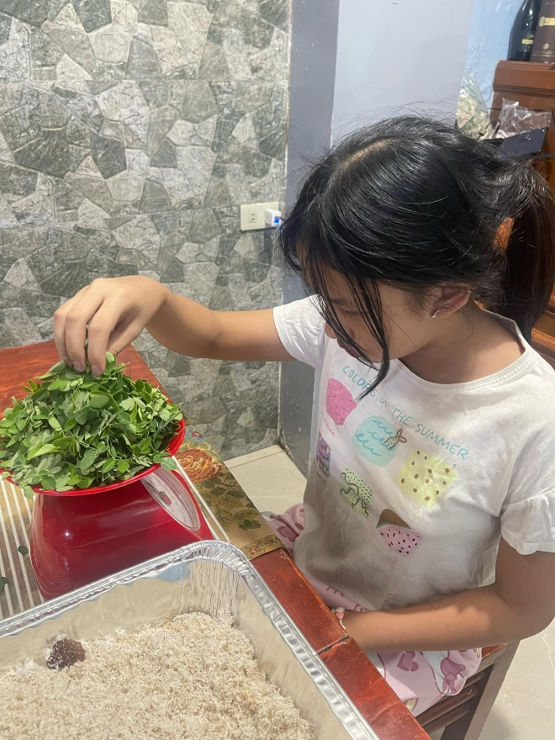

***Figure 8***. Deleaving Malunggay ***Figure 9***. Weighing Malunggay Leaves

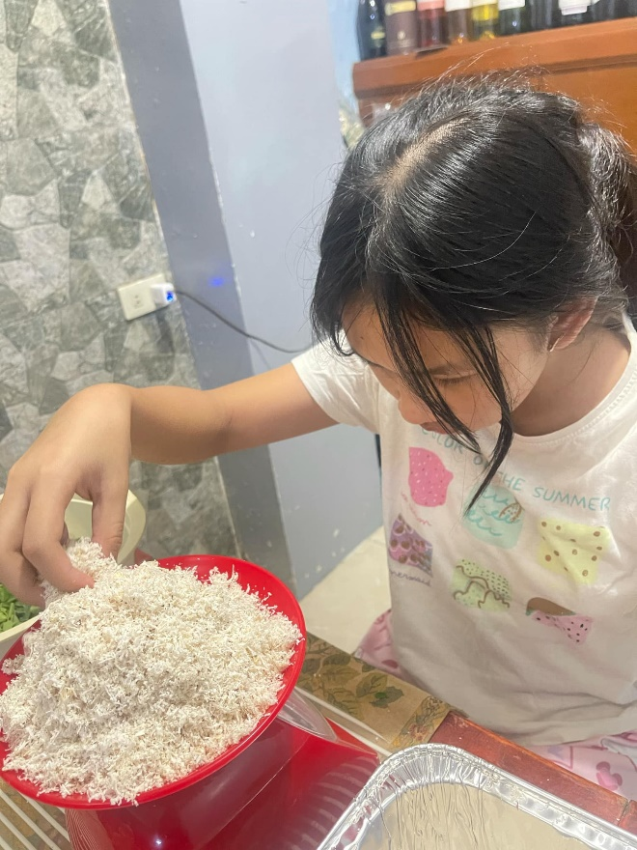 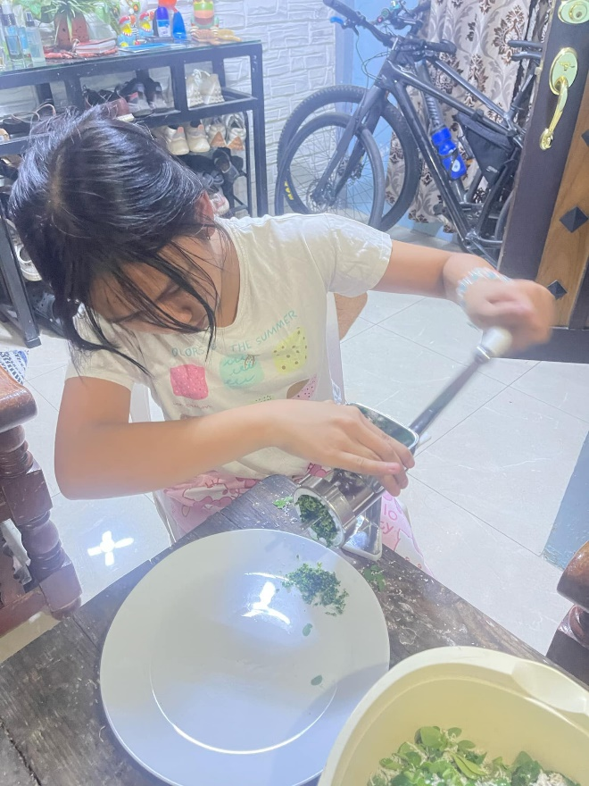

***Figure 10***. Weighing coconut pulp ***Figure 11***. Mulching the mixture

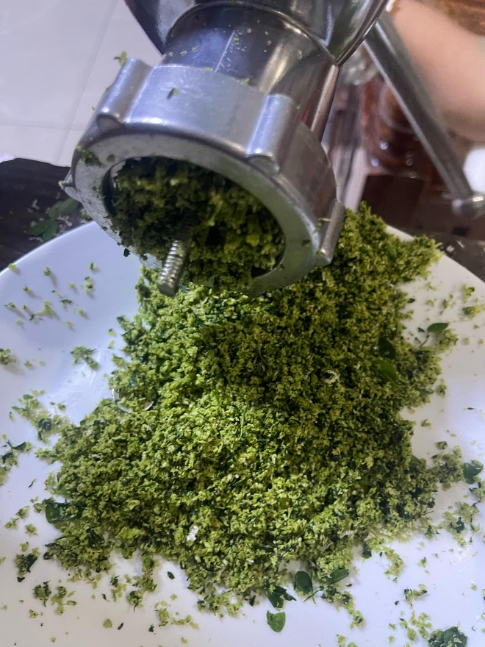 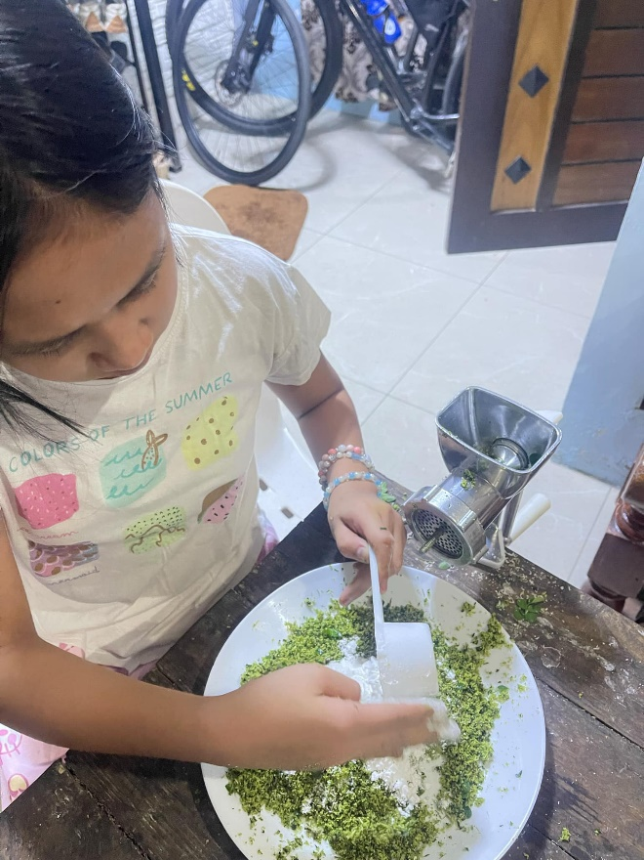

***Figure 12***. Moricoco mulch mixture ***Figure 13***. Adding cornstarch to the mulch

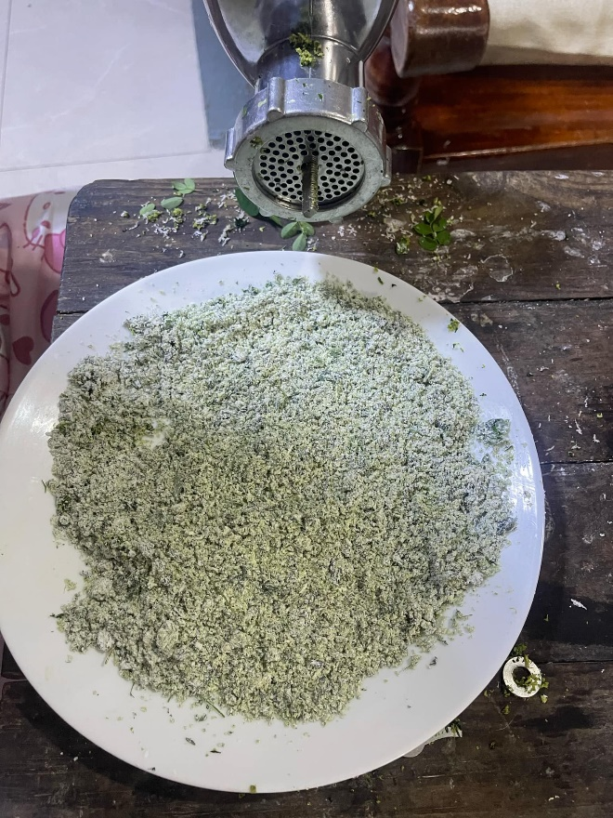 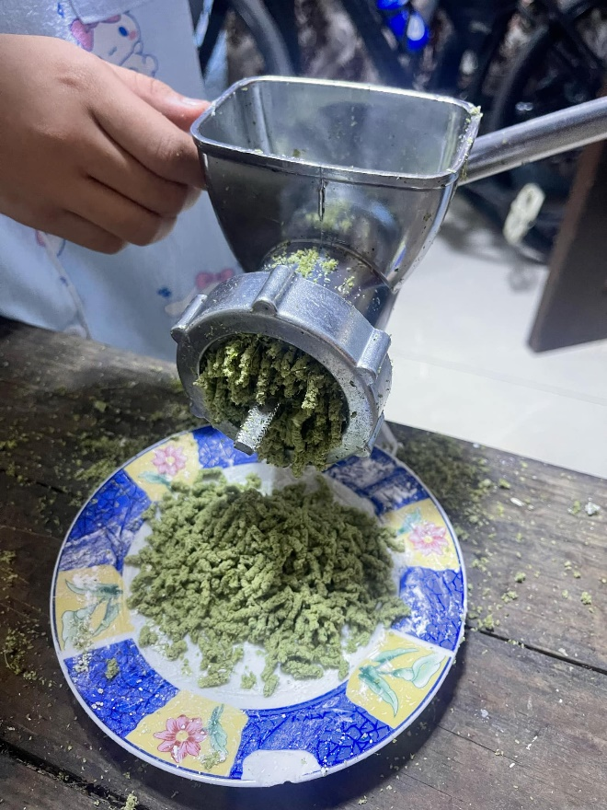

***Figure 14***. Aggregate mixture ***Figure 15***. Pelletizing the aggregate

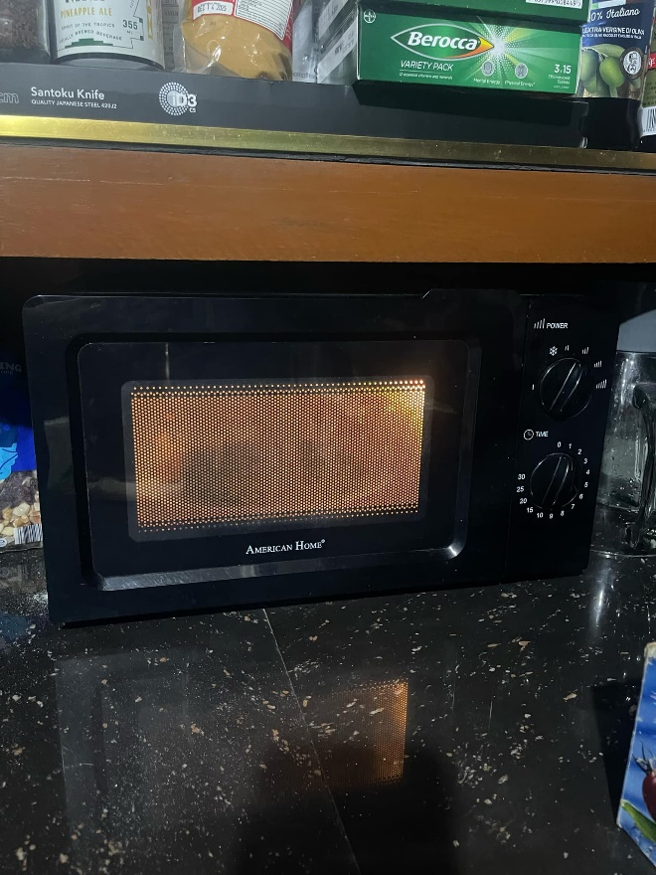 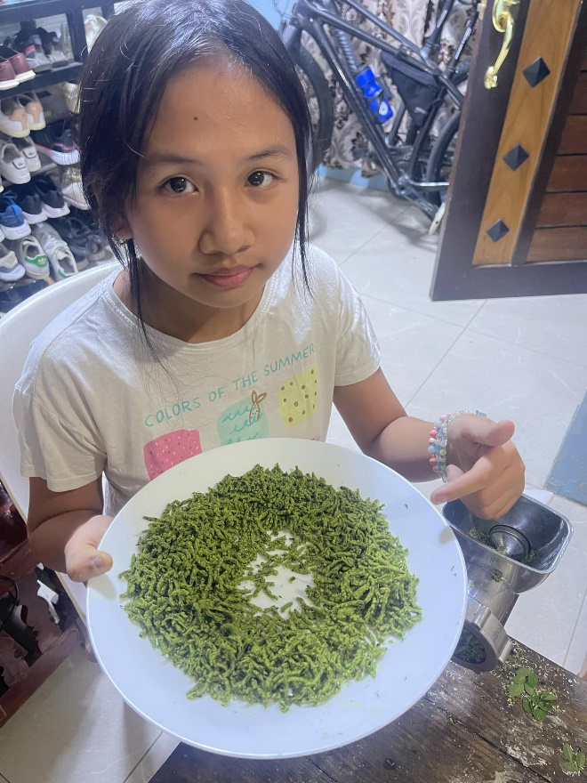

***Figure 16***. Drying the pellets ***Figure 17***. Finished batch

**C. Moricoco Pellets**

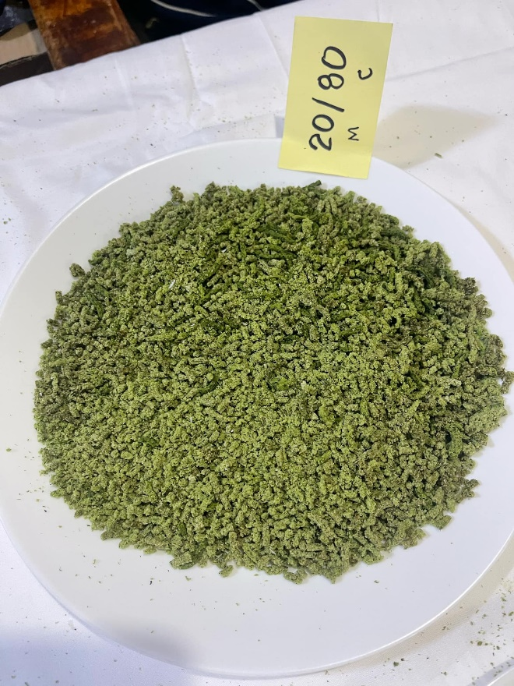 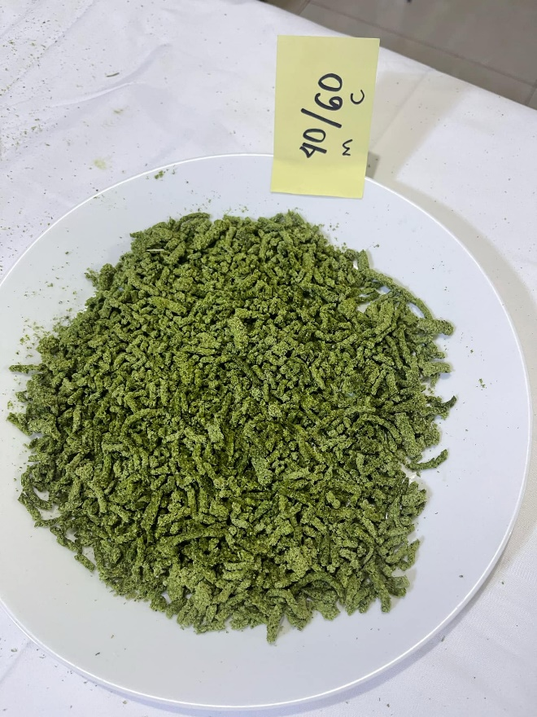

***Figure 18***. 20M80C pellet mixture ***Figure 19***. 40M60C pellet mixture

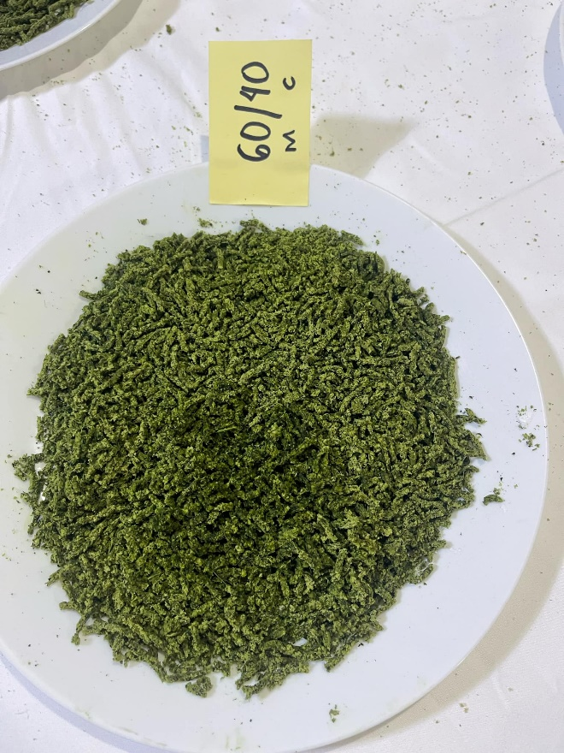 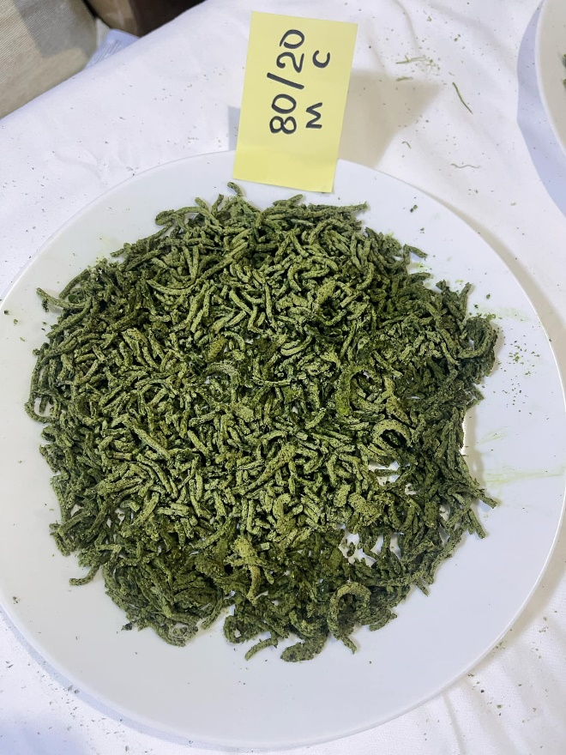

***Figure 20***. 60M40C pellet mixture ***Figure 21***. 20M80C pellet mixture

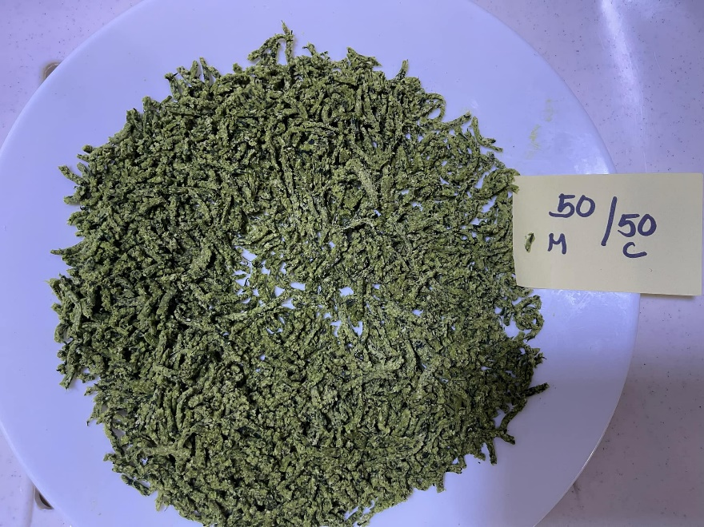 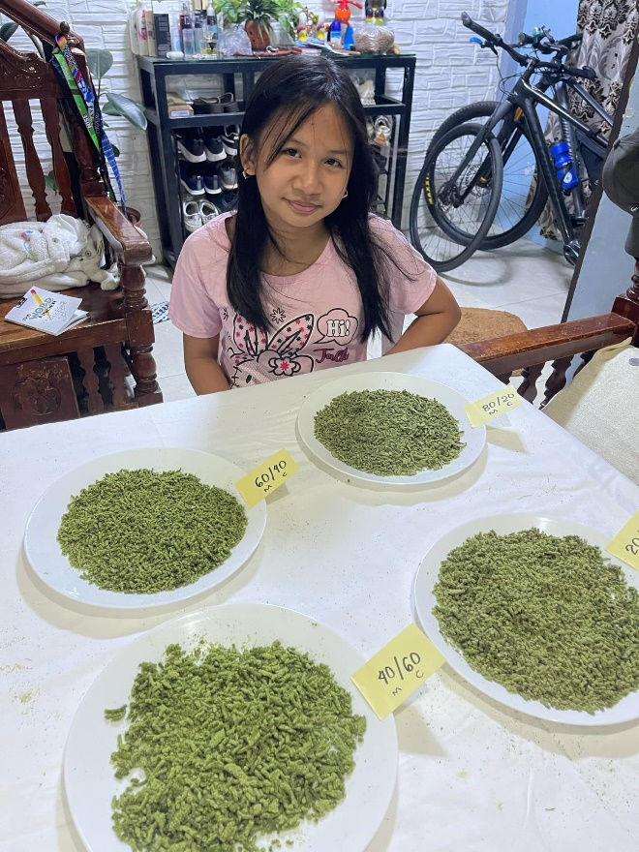

***Figure 22***. 50M50C pellet mixture ***Figure 23***. Researcher with the product batches

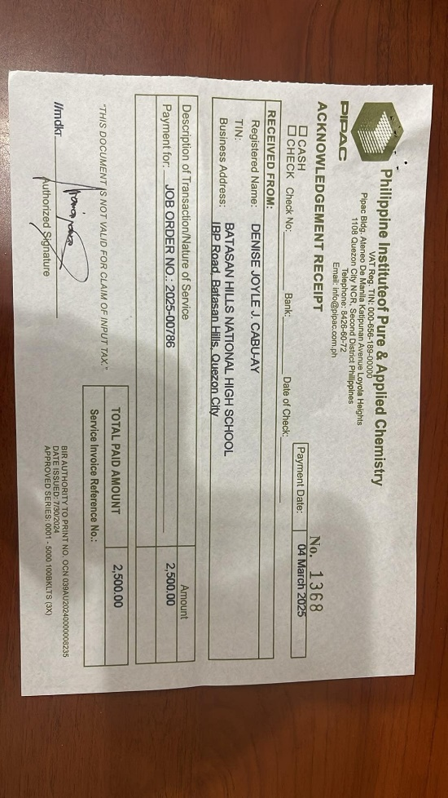 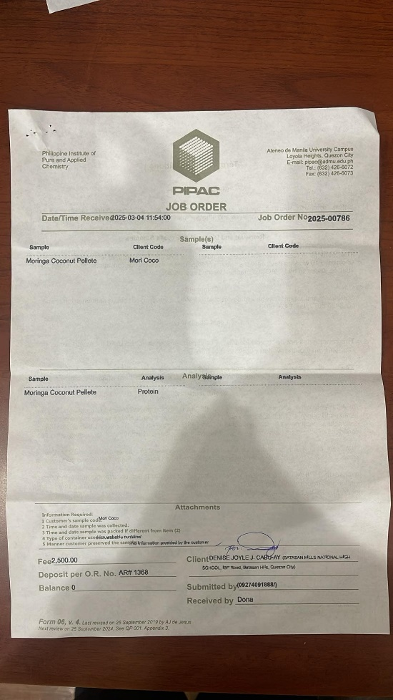

***Figure 24.*** Testing center receipt ***Figure 25*.** Testing center job order